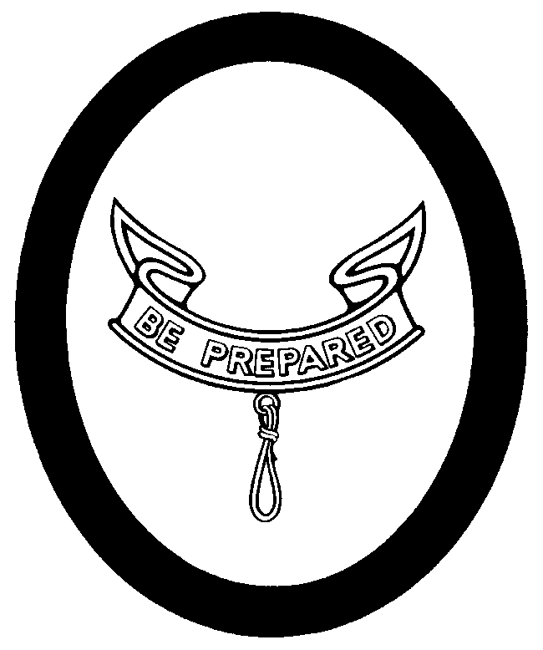
Second Class Personal Growth Agreement Conference

Name: _________________________________Date________ Age: ______ School Grade: ________
I have been in the Scouts for ________ months, including _______ months as a Tenderfoot Scout.
I passed the Progress Revue Board on ____ / ____ / _______

SCOUT SPIRIT:
I have continued to live up to the Scout Spirit by ______________________________________________________
____________________________________________________________________________________________

ADVANCEMENT:
What was the hardest requirement for this rank? _____________________________________________________
From the swimming requirement I learned ___________________________________________________________
From cooking, I learned _________________________________________________________________________
From First Aid, I learned _________________________________________________________________________
What kind of wild animals did you find? _____________________________________________________________
What did you enjoy working on? ___________________________________________________________________
Was it hard to earn your Second Class? ____________________________________________________________

CAMPING:
Since becoming a Tenderfoot Scout, I have participated in the following Camping trips:
_____________________________________________________________________________________________
I liked the ________________________ trip the most because ___________________________________________
The most important things that I have learned from these camp-outs are ____________________________________
_____________________________________________________________________________________________

SERVICE:
I have participated in the following Service Projects since becoming a Tenderfoot Scout:
______________________________________________________________________________________________
I ( ) did, ( ) did not like it because ____________________________________________________________________

PATROL:
My job in the Patrol is ___________________________ To do it, I have to ___________________________________
My Patrol Leader ( ) does, ( ) doesn’t help me. Our Patrol ( ) does, ( ) doesn’t pull together. We
( ) are, ( ) aren’t getting better.

TROOP:
The things that I like most about the Troop are _________________________________________________________
I ( ) do, ( ) don’t like going to Troop meetings. They are __________________________________________________

SCOUT SPIRIT:
I will continue to show my Scout Spirit by _____________________________________________________________

Second Class Personal Growth Agreement Conference Continued

Name_________________________

ADVANCEMENT
What orienteering requirements are needed for First Class? ______________________________________________
______________________________________________________________________________________________
What cooking requirements are needed? _____________________________________________________________
What are the First Aid requirements? ________________________________________________________________
I will try to earn my First Class Progress Award by ______________________________

CAMPING:
I will try to become a more proficient camper by ________________________________________________________
______________________________________________________________________________________________
I will try to take part in ___________________ camping trips before reaching First Class.

SERVICE:
I am trying to learn how to be of service and help to other people. I will try to do it by: ___________________________
______________________________________________________________________________________________

PATROL:
I intend to help my Patrol to become better by _______________________________________________________
Now that I am passing my second stage of Scouting by applying for Second Class, I would like to begin working to become ( ) an Assistant Patrol Leader, ( ) a Den Chief, ( ) Troop Librarian, ( ) Troop Historian, ( ) Member of Troop
Color Guard, or ( ) ______________________________
I think the Patrol can improve by ___________________________________________________________________

TROOP:
I would like to suggest that the Troop do more ________________________________________________________
I think the Troop could do less ____________________________________________________________________
I would like to help the Troop improve by ____________________________________________________________
I ( ) do, ( ) don’t have a friend that I would like to invite to visit the Troop.
If I do have a friend that I would like to invite to visit, I would tell him ________________________________________
_____________________________________________________________________________________________

Respectfully submitted

___________________________________

( ) Accepted
( ) Not Accepted ___________________________________ Scoutmaster Dated: ______ / ____ / ______

Recommendations:

