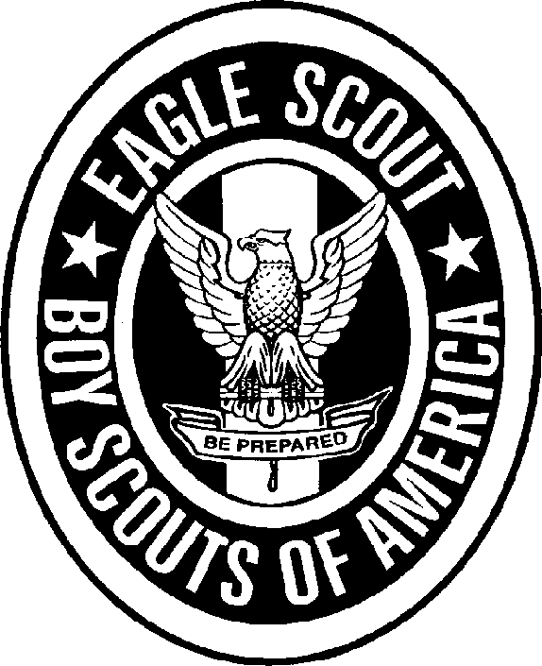

Eagle Personal Growth Agreement Conference
Name: _____________________________________Date____________ Age: ________ School Grade: ________
I have been a member of the Scouts for ____ months, including _____ months as a Life Scout.
I passed the Progress Revue Board on _____ / ____ / _______.

SCOUT SPIRIT:
As a Life Scout I have tried to continue the traditions of Scouting in my life by _______________________________
____________________________________________________________________________________________

ADVANCEMENT:
For my Eagle Scout Progress Award, I have earned the _______________________, ________________________, ______________________, ______________________, _______________________, ______________________, ______________________, ______________________, _______________________, and ___________________
Merit Badges.
The most interesting Merit Badge was __________________ because _____________________________________
_____________________________________________________________________________________________
Of the 11 Merit Badges I have earned, I learned most from ________________________ because _____________________________________________________________________________________________
The best Merit Badge Counselor I have met so far was ___________________________ because _____________________________________________________________________________________________

SERVICE:
For my Eagle Scout Service Project I ________________________________________________________________
_____________________________________________________________________________________________
_____________________________________________________________________________________________
_____________________________________________________________________________________________
_____________________________________________________________________________________________

LEADERSHIP:
As a Life Scout I have served as ___________________. I now understand that true Boy Scouting means BOY LEADERSHIP. I have tried to provide such leadership by _____________________________________________________________________________________________
_____________________________________________________________________________________________

PATROL:
I am ( ) proud of, ( ) disinterested in my Patrol because __________________________________________________
I think it needs __________________________________________________________________________________

TROOP:
I feel that Scouting has taught me ___________________________________________________________________
I believe the Troop ( ) has, ( ) has not provided me with a good Scouting experience.

Eagle Personal Growth Agreement Conference Continued
Name__________________________________________
SCOUT SPIRIT:
Now, that I have achieved the most coveted of all youth awards, I propose to show my pride in the Scout program and myself by _____________________________________________________________________________________

ATTENDANCE:
Troop Meetings ________ out of _________
Campouts _______out of ____________
PLC Meetings ___________out of____________
(Info from Troop Scribe)

ADVANCEMENT:
To continue my quest for the Eagle palm award, I propose to earn the
________________________, ___________________________, ___________________________,
________________________, and ________________________ Merit Badges

SERVICE:
I plan to continue serving others by: ________________________________________________________________

LEADERSHIP:
I realize that now that I am an Eagle, every Scout will be observing the way that I act as well as what I say. To be able to use this attention to the ends of accomplishing things is the true test of Leadership. I propose exert my Leadership by: _____________________________________________________________________________________________

PATROL:
My Patrol, the ___________ Patrol has been my most direct link to the Scouting program I will try to continue to serve and improve it by ____________________________________________________________________________________

TROOP:
I intend to continue to honor the Troop and program that has brought me to this place in my life by: _______________________________________________________________________________________________
** Please attach your life ambitions sheet that you filled out for your Eagle application.

I INTEND TO COMPLETE THE REQUIREMENTS FOR THE EAGLE PALM BY EARNING FIVE ADDITIONAL MERIT BADGES AND CONTINUING TO SERVE MY PATROL BY: _____ / ____ / ________.

Respectfully submitted: _____________________________

( ) Accepted
( ) Not accepted ______________________________ Scoutmaster. Dated ____ / ___ / ______
Recommendations:

