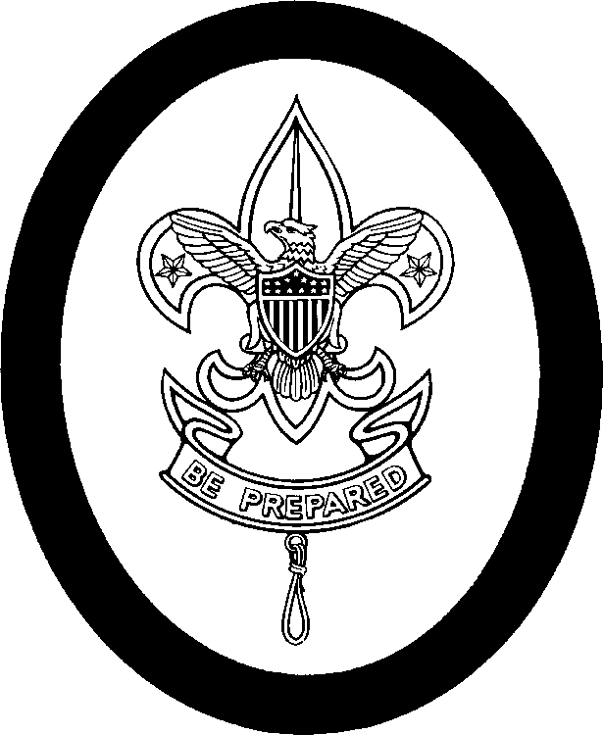

First Class Personal Growth Agreement Conference

Name: _________________________________Date________ Age: _____ School Grade: _______
I have been a member of the Scouts for _____ months, including _______ months
As a Second Class Scout. I passed my Progress Revue Board on ____ / _____ /_____

SCOUT SPIRIT:
I have shown my Scout Spirit by _______________________________________________________________

ADVANCEMENT:
From orienteering, I learned __________________________________________________________________
From cooking, I learned ______________________________________________________________________
From swimming, I learned ___________________________________________________________
How well can you tie the bowline knot and rescue bandages? _________________________________________
From your lashings, you learned _______________________________________________________________
Have you earned any Merit Badges? ____________________________________________________________
I find the difference between Progress Awards and Merit Badges is: ____________________________________
_________________________________________________________________________________________
I have appeared before ____ Troop Progress Review Boards. I think they are:
_________________________________________________________________________________________

CAMPING:
I have completed _____ nights of camping since joining the Troop.
Since becoming Second Class, I have been on the following campouts: _________________________________
__________________________________________________________________________________________
I liked the ________________ trip the best because ________________________________________________
Camping-out has taught me: ___________________________________________________________________

SERVICE:
I ( ) do /( ) don’t try to do a “Good Turn” daily. I have helped others by ___________________________________
________________________________________________________________________________

PATROL:
My Patrol is ( )poor ( ) fair ( ) good ( ) great. My job is ________________________________________________
I try to help the Patrol by _______________________________________________________________________
We meet ( )rarely ( ) don’t ( ) occasionally ( ) regularly. We do things to prepare for Troop Meetings. Yes No
We have a Patrol ( ) song, ( ) yell, ( ) flag, ( ) mobilization plan, ( ) meeting place, ( ) storage area.

TROOP:
I think the TROOP is ( ) Great, ( )Good, ( ) Fair, ( ) Mediocre, ( ) Poor
The things that I like most about being in the Troop are: _____________________________________________
The things that I enjoy the least are: _____________________________________________________________
I think being in the Scouts is: ___________________________________________________________________

First Class Personal Growth Agreement Conference Continued
Name______________________________

SCOUT SPIRIT:
I will continue to show my Scout Spirit by ________________________________________________________

ADVANCEMENT
I know that the skills portion of my advancement is now completed. From now on,
I will earn my Progress Awards by earning Merit Badges. I will continue to practice
The skills that I have learned and will try to teach the newer Scouts entering the
Troop these skills. _________ For my Star rank, I intend to pass these Merit Badges.
________________, ______________, ________________, ________________,
________________, ______________. Please circle the badges required for Eagle.
I have chosen these badges because __________________________________________________________
________________________________________________________________________________________

SERVICE:
For my Star Scout Service Project, I propose to __________________________________________________
_______________________________________________________________________________________

LEADERSHIP:
For my Leadership requirements for Star Scout, I submit that I will serve the Troop or
my Patrol in the following manner or position. ___________________________________________________
_______________________________________________________________________________________

PATROL:
I will continue to try to help my Patrol by ________________________________________________________
_______________________________________________________________________________________

TROOP:
I hope to see the Troop ____________________________________________________________________
I will help by _____________________________________________________________________________

** YOU WILL BE ASKED TO KEEP A NOTEBOOK TO LOG YOUR ADVANCEMENTS, SERVICE,
CAMPING, AND LEADERSHIP.

I INTEND TO COMPLETE THE REQUIREMENTS FOR STAR SCOUT BY _________/ _____/ ______

Respectfully submitted: ____________________________
( ) Accepted
( ) Not accepted _______________________________Scoutmaster. Dated ___/ __/ __
Recommendations:

